

CHALLENGE NAME: Patterns   
DEV : Aaditya

CATEGORY: Crypto   
LEVEL: Hard

2025



**Challenge Description**:

You gotta pull the pen and paper out!

The flag is given in three parts. Images of the below three parts are provided.

Part 1: {FsTwizCphdVhjha

Part 2: 3yo30vi_y0xq7rsd_kigdemwh0rqjbogqucvwqd_ilqalbjabbwg

Part 3: }g1te_x5j8u5bon4

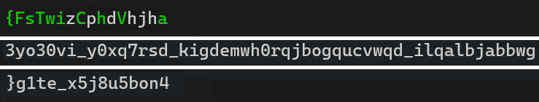

**Solution:**

1. If the letters in green in part 1 were observed, they were just “VishwaCTF{“ jumbled.
2. If the indices of the green letters in the order of “VishwaCTF{“ in the first part of flag were observed, were following a [Collatz Sequence](https://www.bing.com/ck/a?!&&p=ba103fef398e2a5e7b2d5297a91bdf99cc95c4582c79ae320ac18c2e426c08b9JmltdHM9MTc0MTEzMjgwMA&ptn=3&ver=2&hsh=4&fclid=01bc6373-2167-6334-2060-70452072623b&psq=collatz&u=a1aHR0cHM6Ly9lbi53aWtpcGVkaWEub3JnL3dpa2kvQ29sbGF0el9jb25qZWN0dXJl&ntb=1), which could either be found out by observation or by using AI.

Sources below :

1. <https://www.perplexity.ai/search/12-6-3-10-5-16-8-4-2-1-what-pa-23DBdym5RyCg83bg5qiqiw?newFrontendContextUUID=4e4e6e7f-0084-4232-8f3d-04b9dcd31a91>
2. <https://chatgpt.com/share/67c840b3-6c30-800a-a3a4-018b443b606a>
3. <https://claude.ai/share/7b826d90-2640-48ff-bd32-5f6085ec06fd>
4. If for every index of other parts’ strings (part 2 and part 3), a Collatz sequence was made, one can find the relevant word by writing code. (A Rough solving code is given in the repository)
5. The Output for the code is below:

Part 1

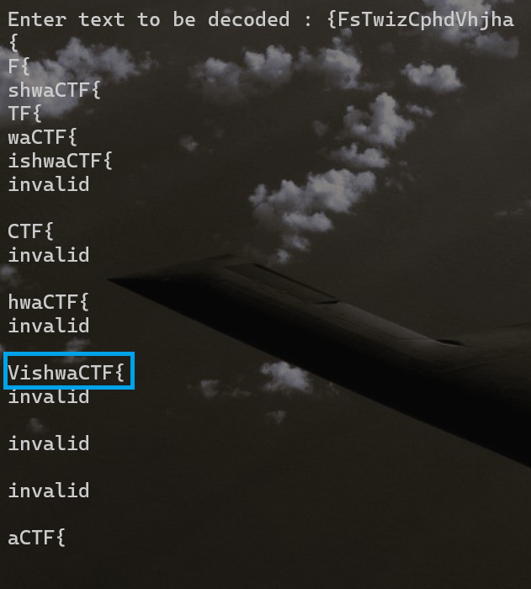

Part 2

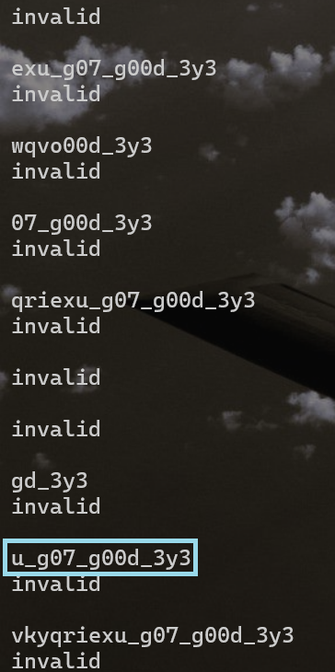

Part 3

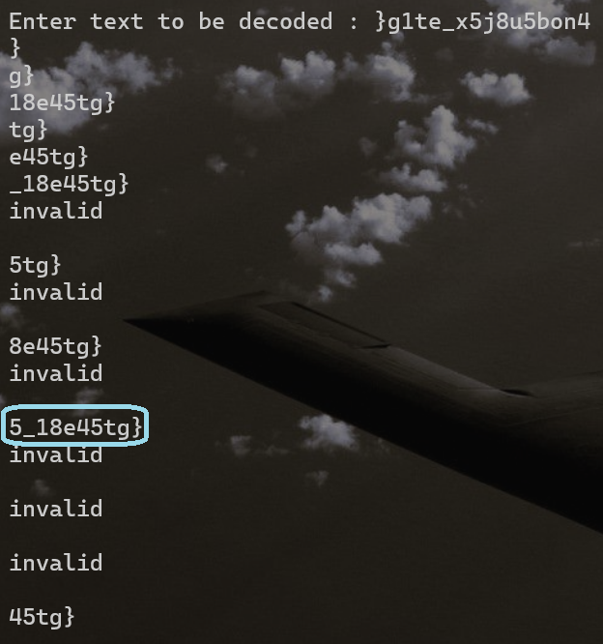

On combining the three parts (the last part can be selected by the logic that the text should contain “eyes” (3y35)), we get the required flag.

**Flag:** VishwaCTF{u_g07_g00d_3y35_18e45tg}

